A CRM Application For Wholesale Rice Mill

**1.What Is Salesforce?**

Salesforce is your customer success platform, designed to help you sell, service, market, analyze, and connect with your customers.

* 1. **Creating Developer Account**

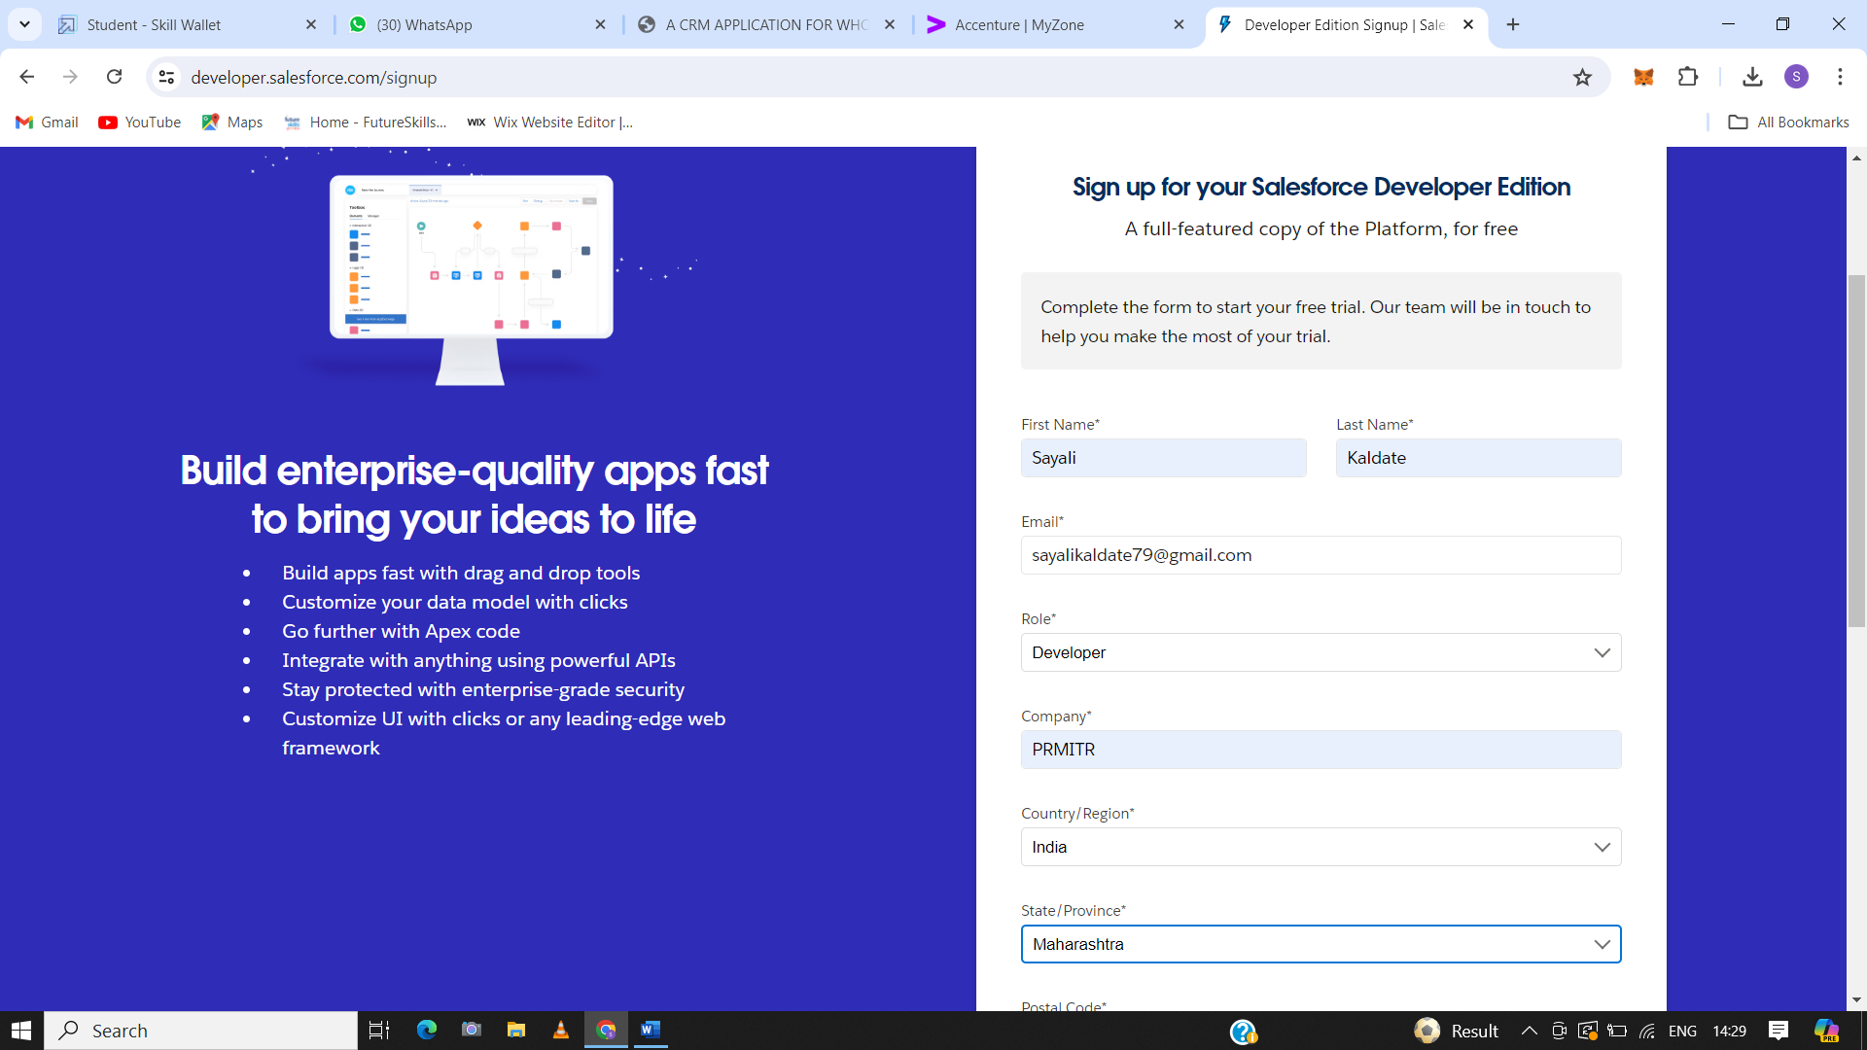

* 1. **Account Activation**

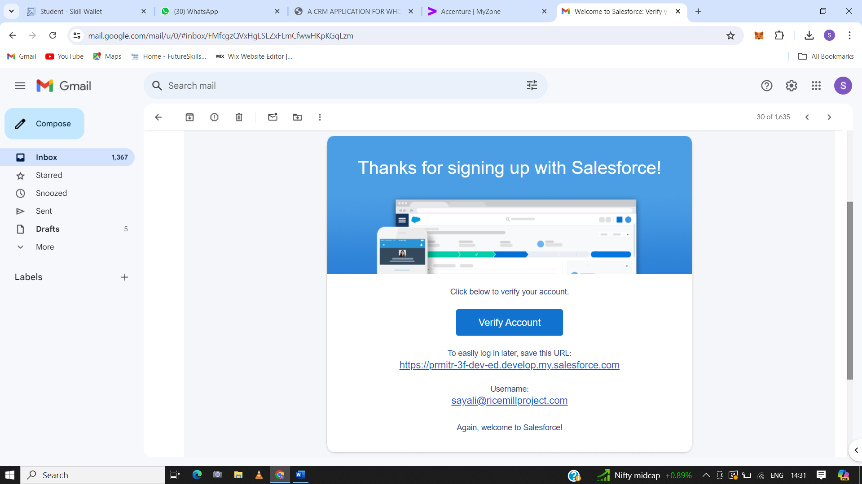

1. **Object**

What Is an Object? Salesforce objects are database tables that permit you to store data that is specific to an organizationWhat Is an Object? Salesforce objects are database tables that permit you to store data that is specific to an organization

* 1. **Create Supplier Object**

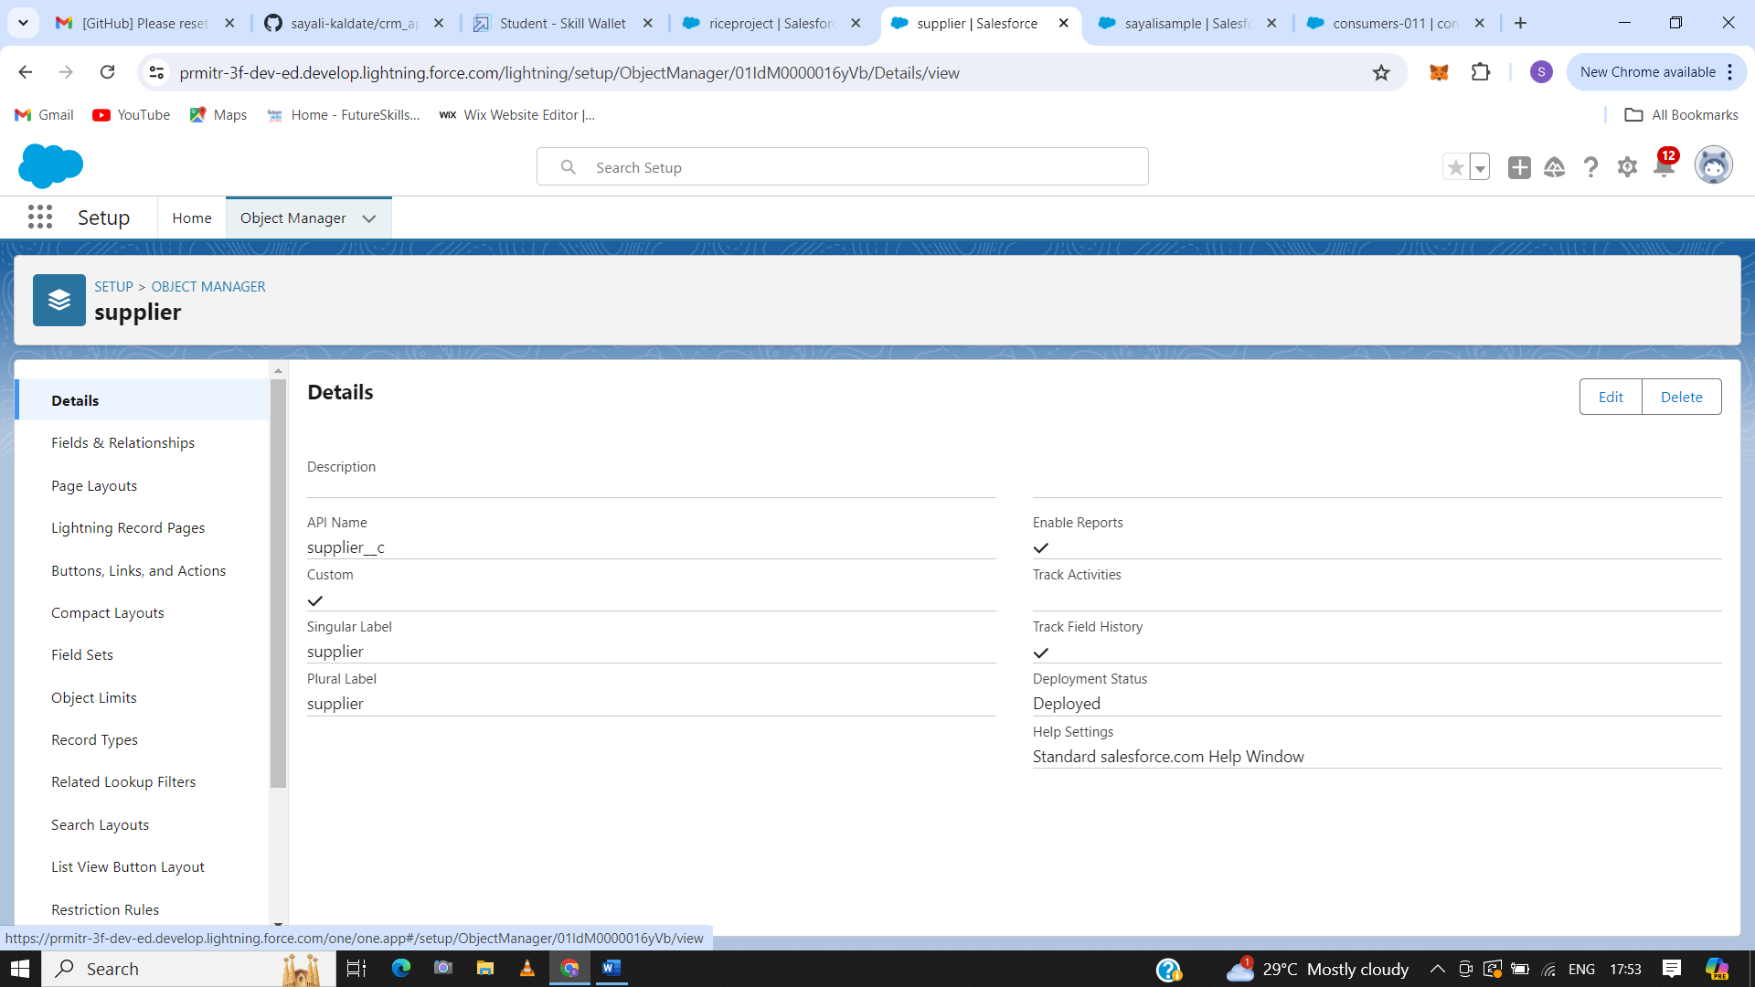

### 2.2. Create Rice Mill Object

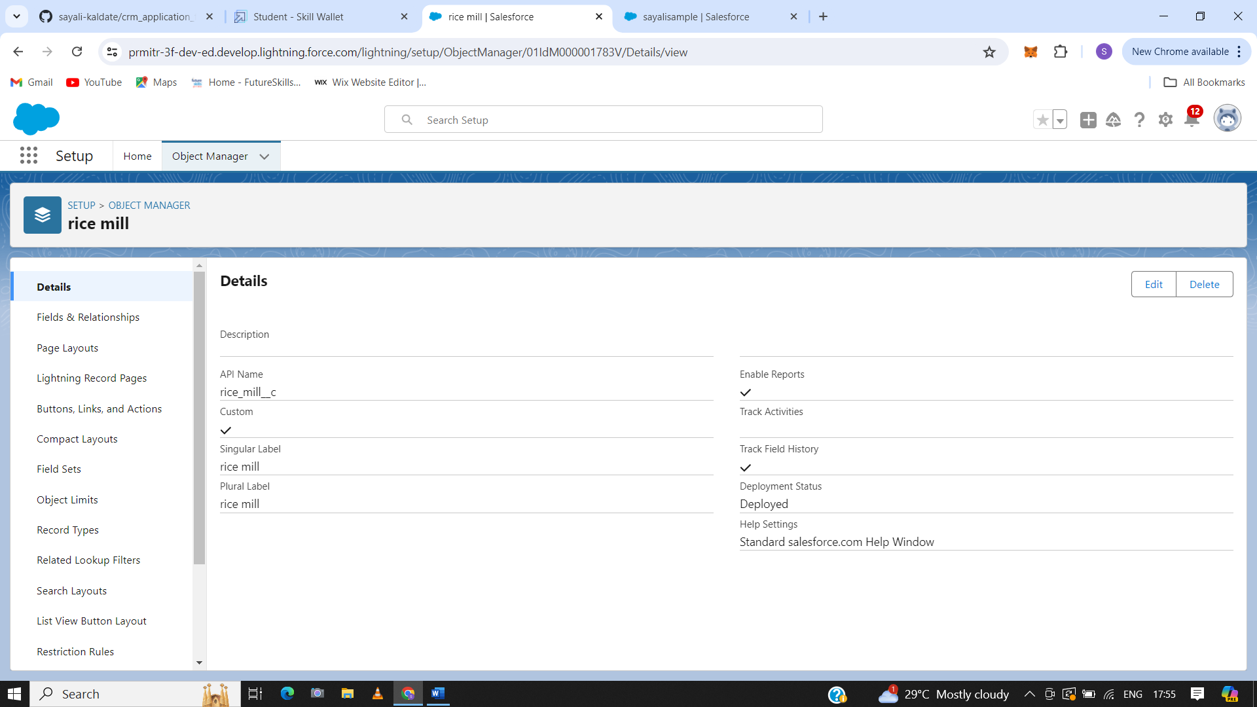

### 2.3 Create Consumer Objects

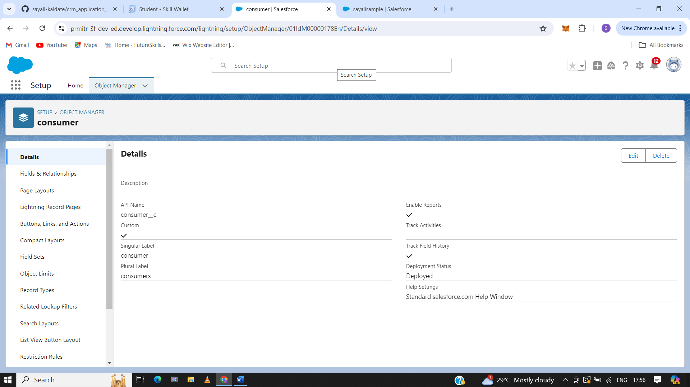

### 2.4. Create Rice Details Objects

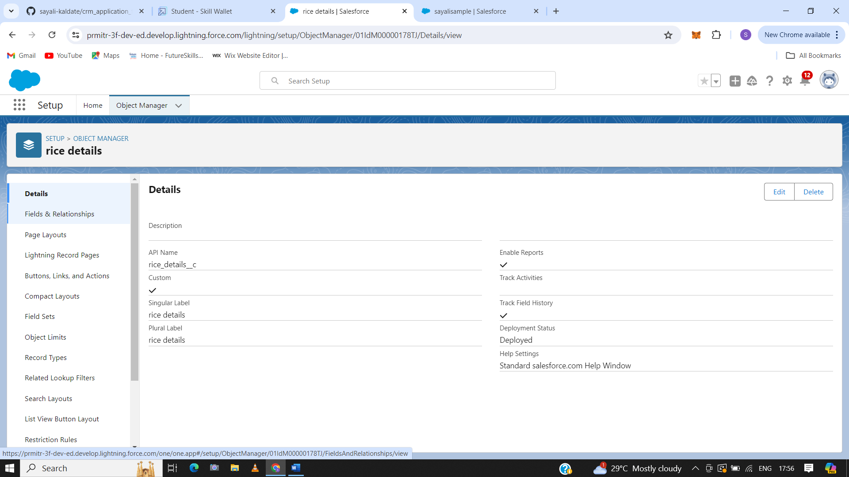

1. **Tab**

A tab is like a user interface that is used to build records for objects and to view the records in the objects.

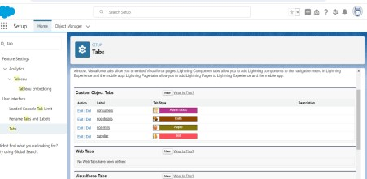**3.1 Custom Tab**

**3.2 Rice Mill Tab**

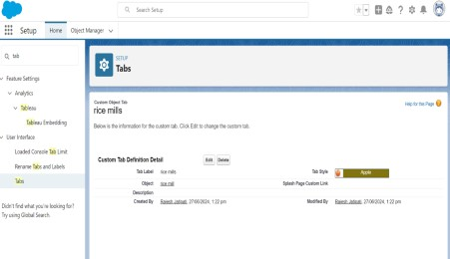

## **3.3 Consumer Tab**

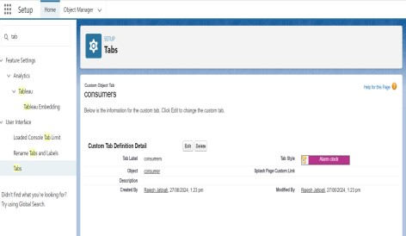

**3.4 Rice Details Tab**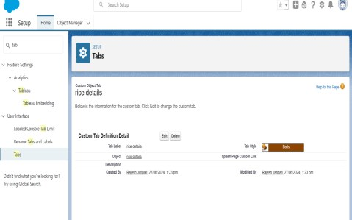

### Page Layout

### a page layout is a framework that controls how users can see and interact with a record on an object record page.

### 4.1 Creating The Page Layout

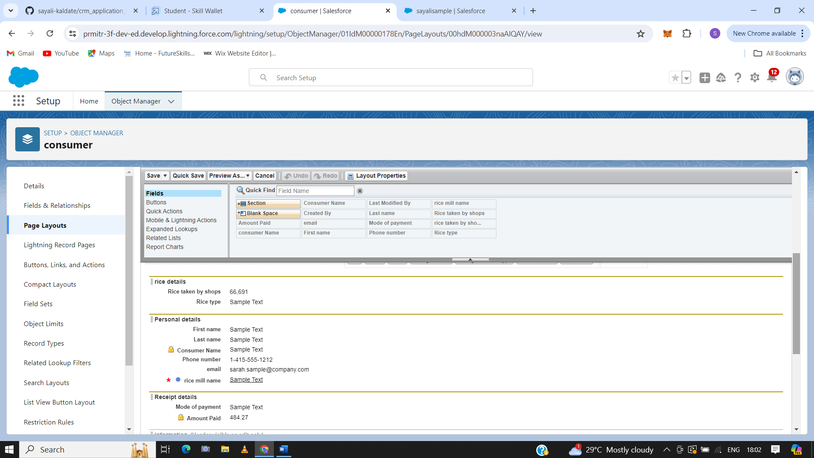

### Create User

### A user in Salesforce is anyone who logs in to Salesforce and uses it to access data. Users can be employees, customers, or partners of an organization, and can be human or non-human. For example, Salesforce Integration users can be non-human users that are used for automated work.

* 1. Vicky y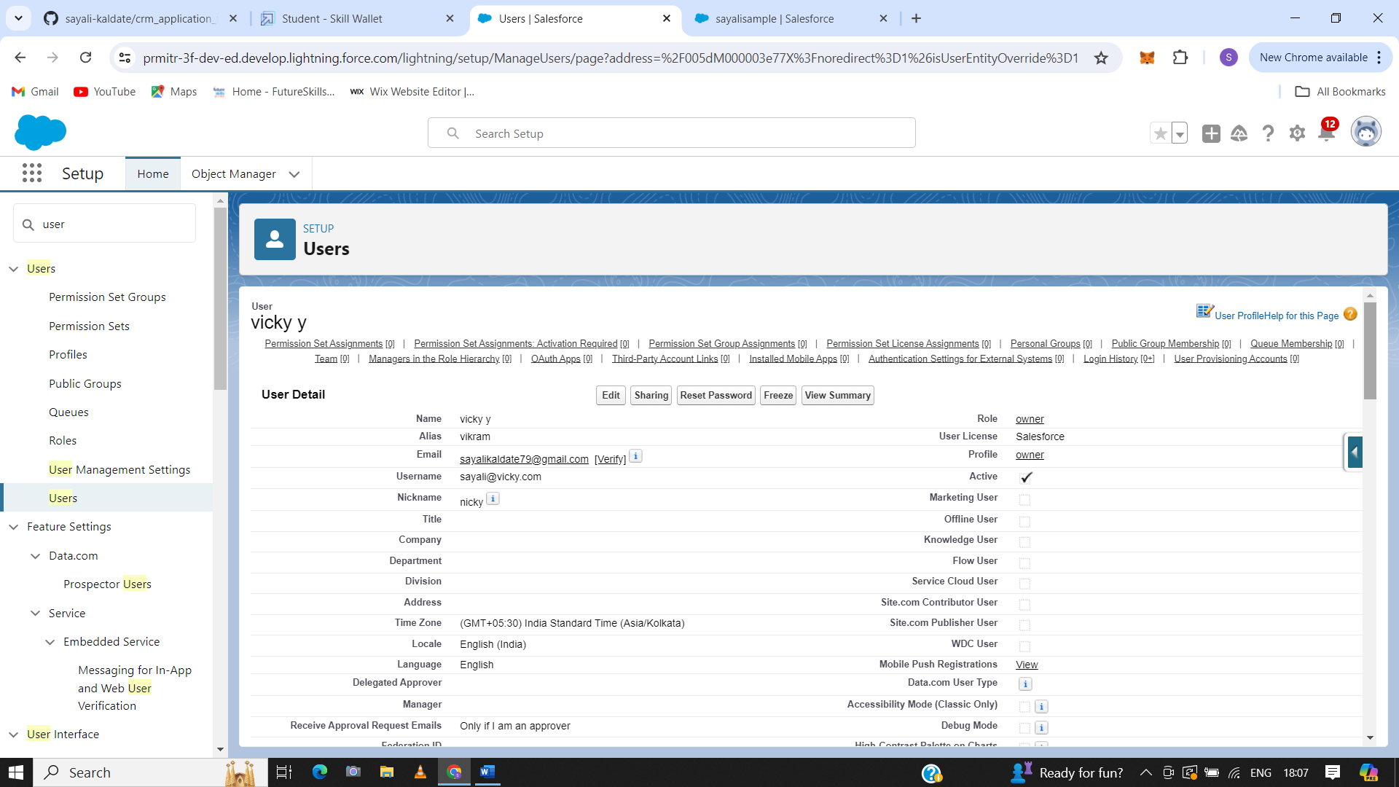
  2. Ram Ram

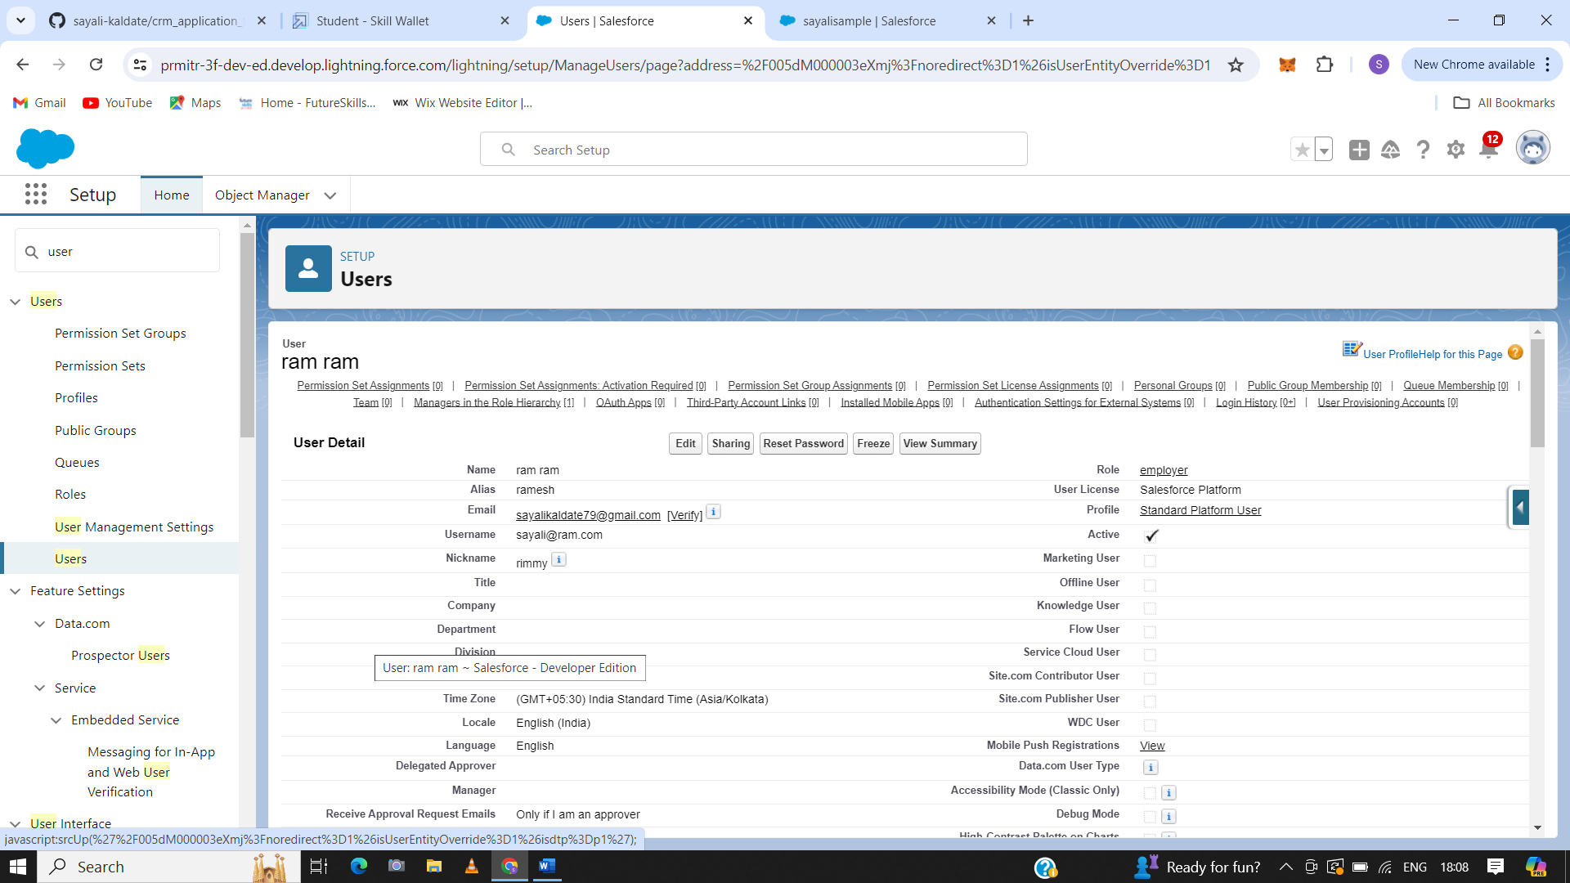

* 1. Ragu Raj

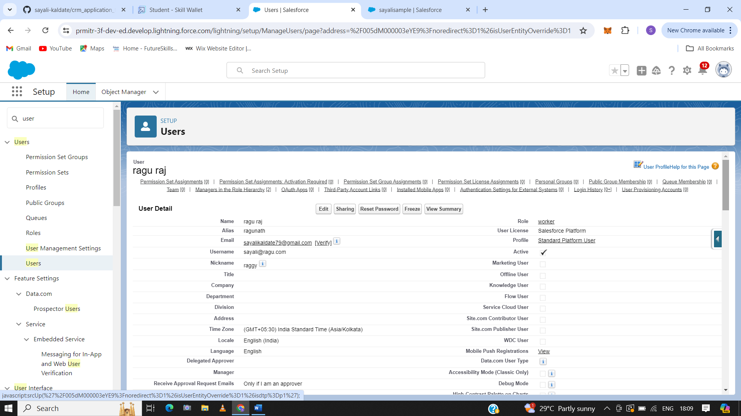

### OWD

### Organization-Wide Defaults (OWD) in Salesforce are settings that define the default level of access users have to records in an organization.

### 6.1. Creating OWD Setting.

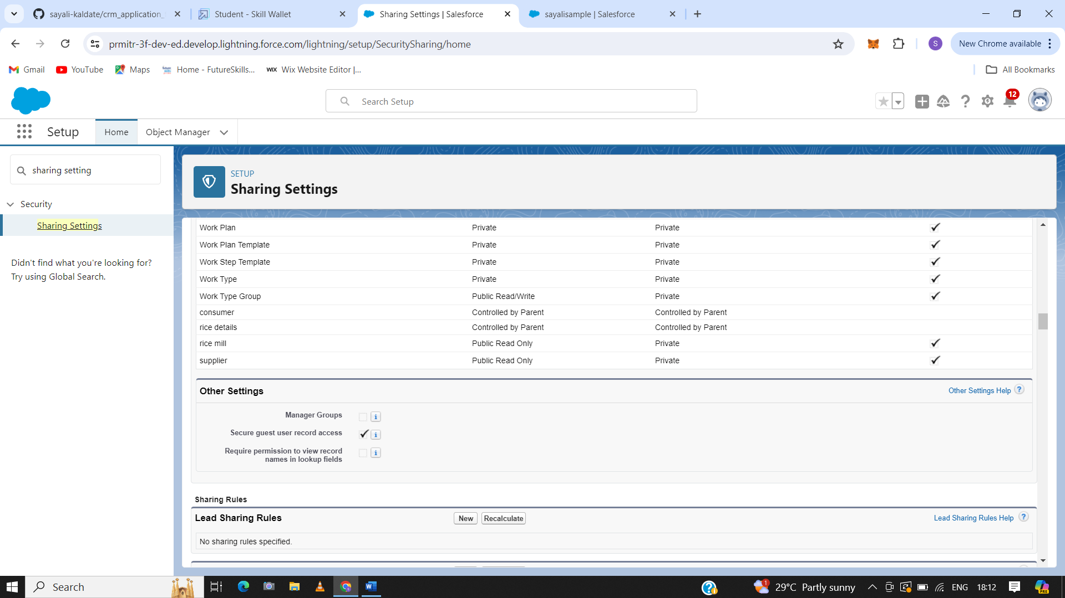

1. **Report**

Reports in Salesforce are a collection of records displayed in a list format that can be filtered or grouped by any field. They can be tabular or similar to tabular, with the option to display charts. Reports are a powerful tool that help users analyze and visualize their data.

**7.1. Create Report**

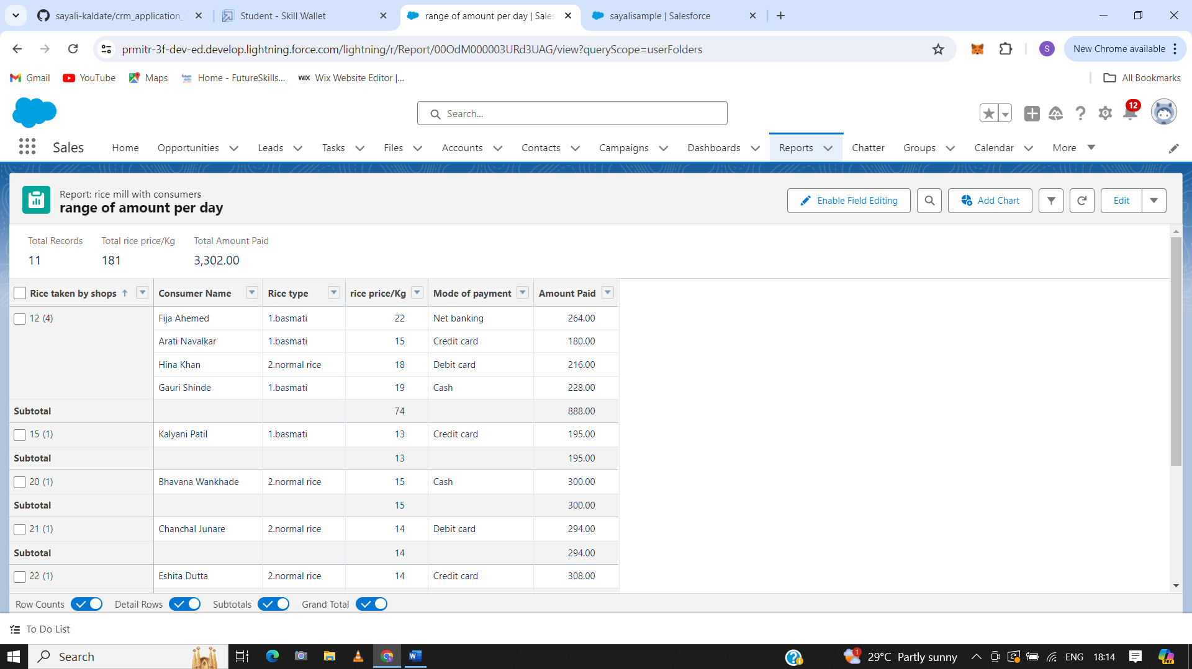

1. **Dashboard**

A Salesforce dashboard is a visual tool that displays data from Salesforce reports in a graphical layout. Dashboards can help users understand business conditions, identify trends, and make data-driven decisions. They can also help users monitor operations, optimize processes, and improve overall business performance

**8.1. Create Dashboard Folder**

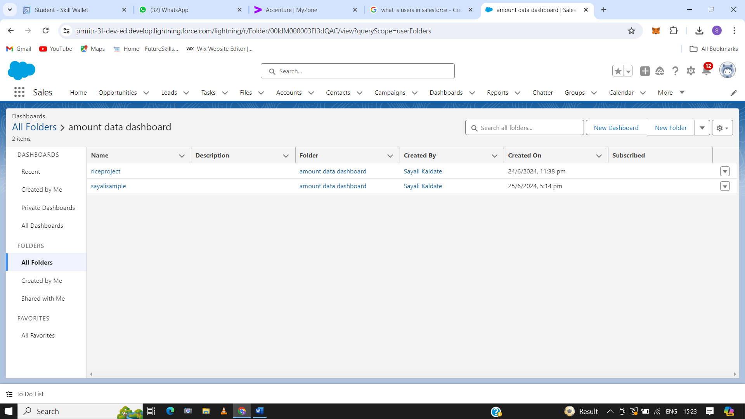

### 8.2.Create Dashboard

1. Vertical Bar Chart

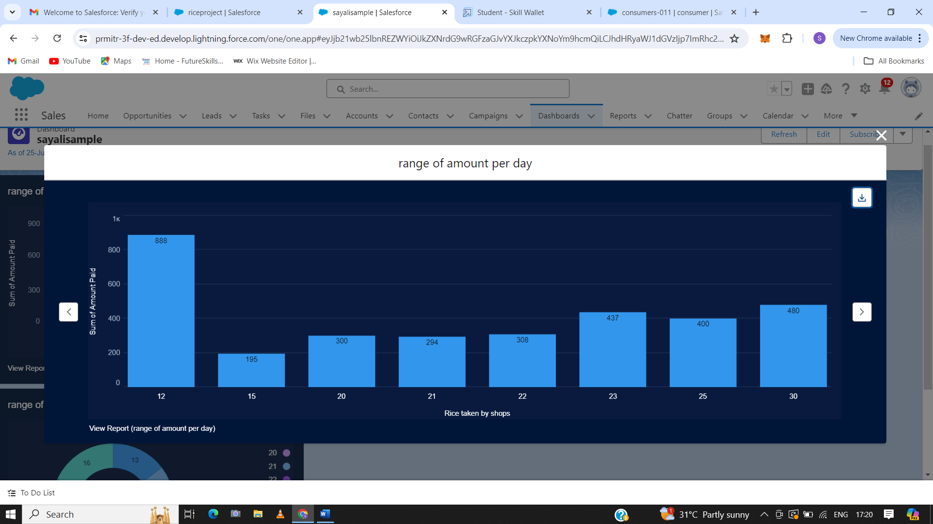

1. Donut Chart

